What to Wear to the Wedding

Dear Culture Contrarians,

Even the poorest country in the world (Burundi) celebrates weddings. Every woman desires to be beautiful on her wedding day.

For more than 10 years Bethany Bible Church has partnered with Stephanie, Anicet’s wife, in her wedding dress rental business. I have seen her shop–fully equipped with a Singer treadle machine. This year donations were scarce and thrift shops sparce, so I scoured Facebook Market place, determined to bag my limit at $50 per dress. I shared with whomever would listen the reason why I wanted their dress. It does, after all, look a bit scary for a 70-year-old male to endeavor to purchase a wedding dress.

Lisa Dean, of Divine Wedding Details, was my last stop. For many years she has served the Lord and our community as a wedding planner, and from time to time finds herself with wedding dresses that no one wants. As Sara and I visited with her, she gave us the dress she was selling and then asked if we would like another dress. Yes, of course! She went upstairs and brought down her very own wedding dress, perfectly preserved in museum-quality cases, and handed it over to us like a beloved child.

Our Savior looks forward to the presentation of His bride—the Church—to Himself (Eph. 5:26), and we want to be beautiful for Him at that future wedding ceremony. The gracious, joyous giving of precious things for the celebrations of others who cannot afford lovely things is the essence of beauty.

“And I heard, as it were, the voice of a great multitude, as the sound of many waters and as the sound of mighty thunderings saying, ‘Alleluia! For the Lord God Omnipotent reigns! Let us be glad and rejoice and give Him glory, for the marriage of the Lamb has come, and His wife has made herself ready.’ And to her it was granted to be arrayed in fine linen, clean and bright, for the fine linen is the righteous acts of the saints.” Revelation 19:6-8

Our marriage to the Lamb is getting closer…let’s be eager—and ready!
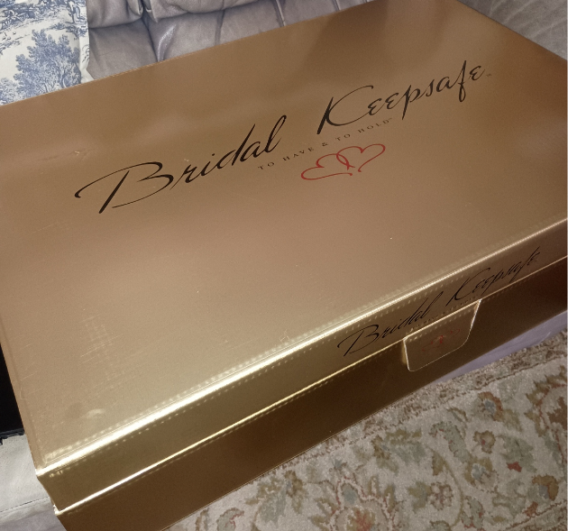  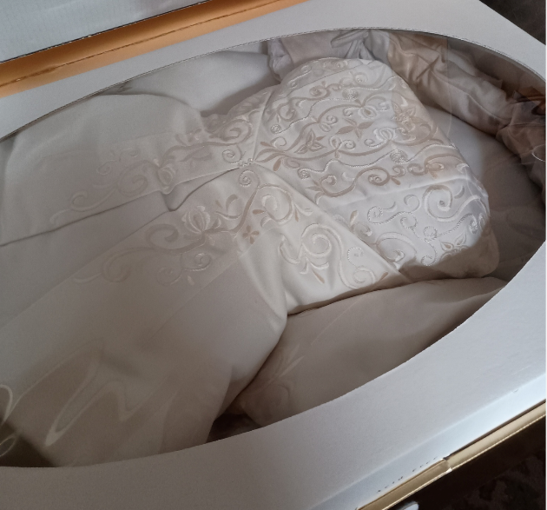 | 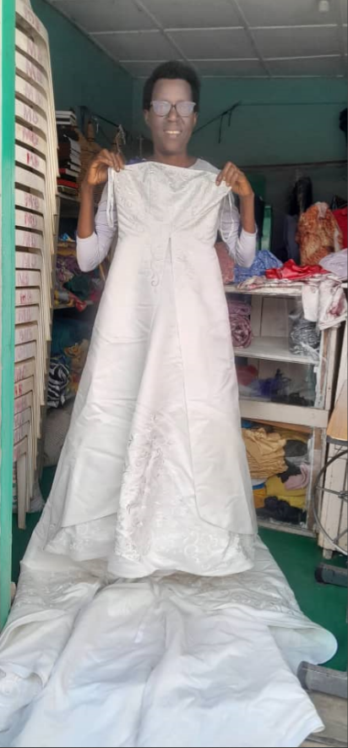
My love to you all,

